 | INSTITUTE OF SPACE TECHNOLOGY  KICSIT · KAHUTA CAMPUS  Department of Computer Science | 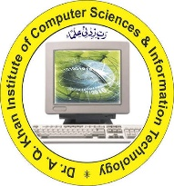

ASSIGNMENT
Mobile App Development (Lab) · 1 Credit Hours
TASK DETAILS
Assignment | Assingment No 1
Topic | Proof of AI Integrated App
Date of Submission | 06/11/2026
SUBMITTED BY
Student Name | M.Tabish Husnain
Registration No. | 242201065
Program | BS Computer Science
Semester | 5th Semester
SUBMITTED TO
Instructor | Sir Uzair

Code Implementation and Output Documentation:
1. Code Implementation & Core Logic:
The following section highlights the critical code logic used to develop the Scholar Lens application, focusing on Edge AI integration, secure file handling, and application architecture.
Code Snippet 1: Project Dependencies & Setup
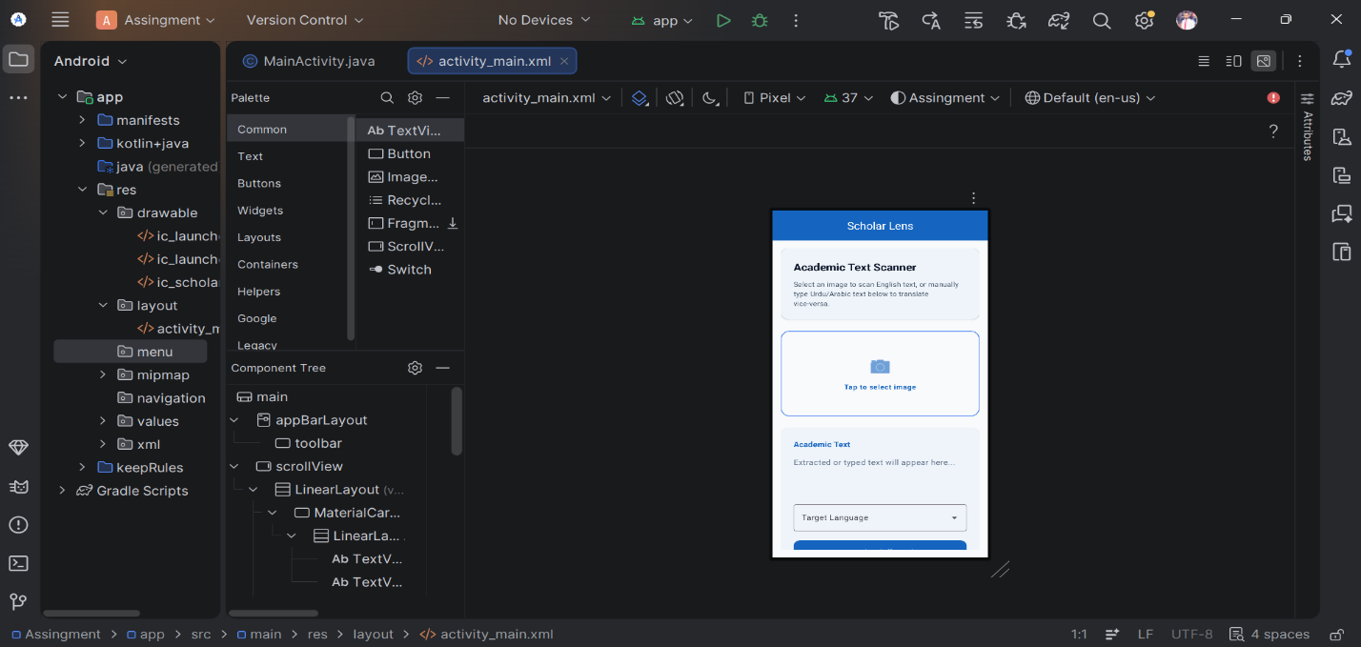
Description: This snippet demonstrates the project's foundation. It highlights the integration of Google ML Kit dependencies required for offline processing (Text Recognition, Translation, and Language Identification). It also shows the UI components utilized to ensure the application remains powerful without relying on cloud API keys.
Code Snippet 2: Application Manifest & Splash Screen Configuration
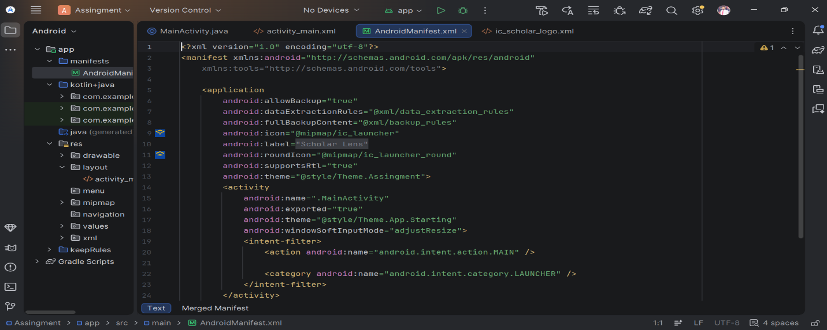
Description: The AndroidManifest.xml serves as the blueprint of the application. This snippet highlights the zero-permission architecture (notice the absence of invasive storage or internet permissions). It also shows the application theme being pointed to the custom Splash Screen theme (Theme.App.Starting), ensuring a branded initial launch.
Code Snippet 3: Main Activity Initialization
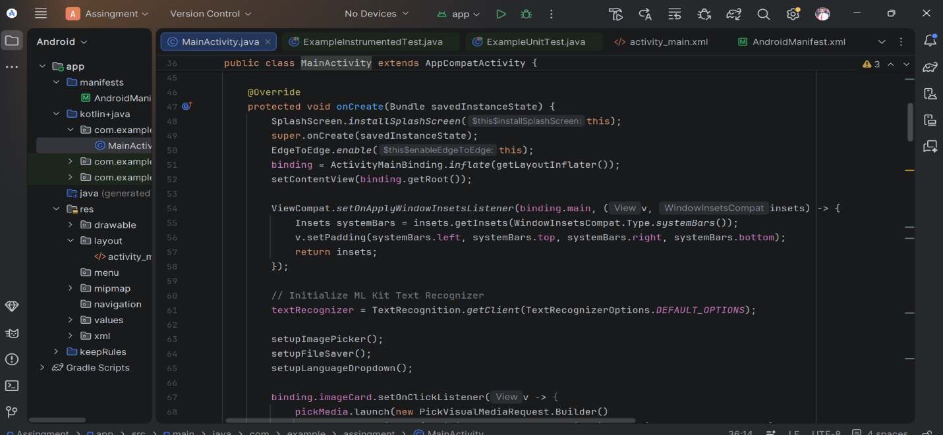
Description: This logic shows the onCreate lifecycle method in MainActivity.java. It demonstrates the initialization of the AndroidX Splash Screen API, the ViewBinding for the UI layout, and the instantiation of the ML Kit TextRecognizer client utilizing default options for on-device OCR.
Code Snippet 4: Secure Image Picker Implementation
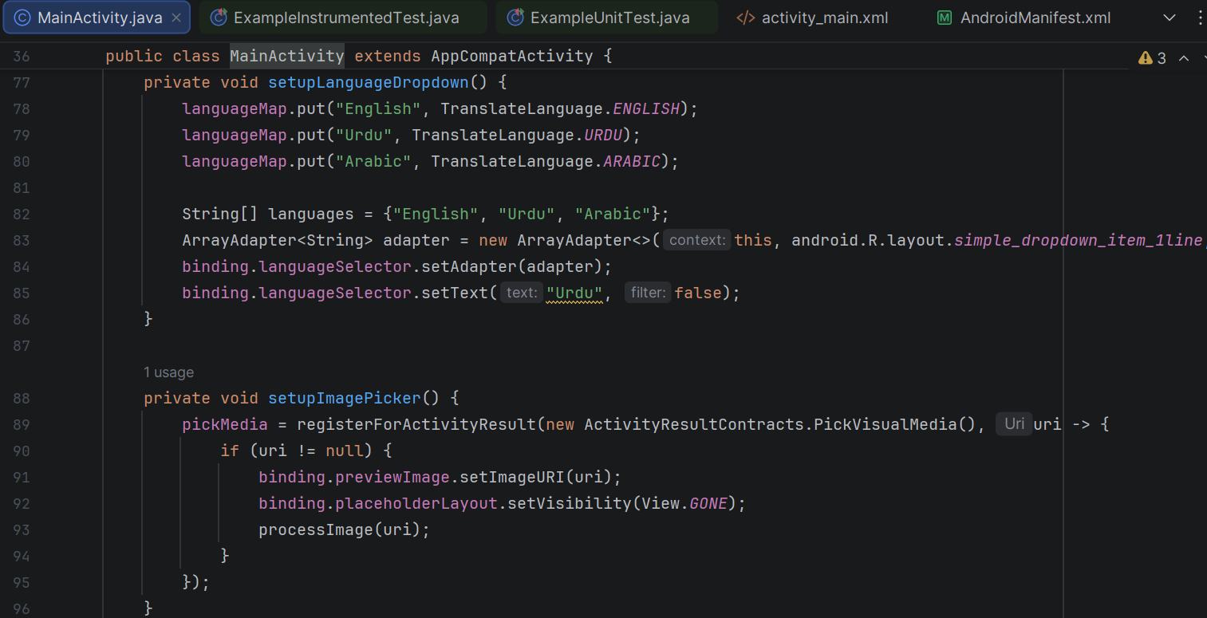
Description: This snippet showcases the implementation of Android's modern ActivityResultContracts.PickVisualMedia. Rather than requesting dangerous storage permissions to read the user's gallery, this code securely delegates image selection to the OS.
Code Snippet 5: Optical Character Recognition (OCR) Processing
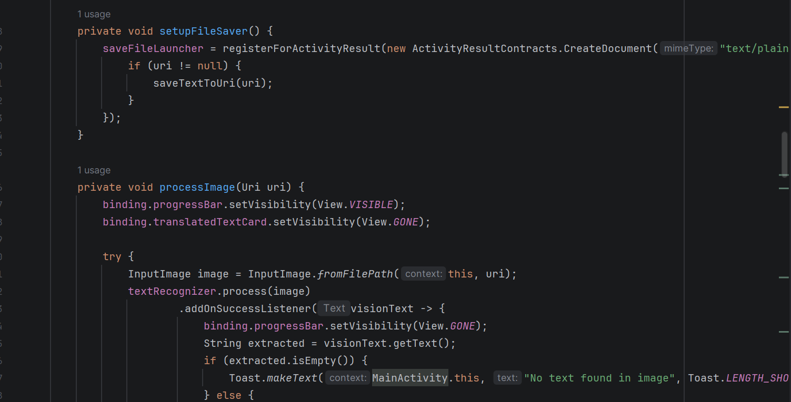
Description: This is the core Vision AI logic. An InputImage is generated from the user's selected URI and passed to the offline TextRecognizer. The success listener extracts the academic text and safely populates it into the UI's editable text field.
Code Snippet 6: Dynamic Language Identification
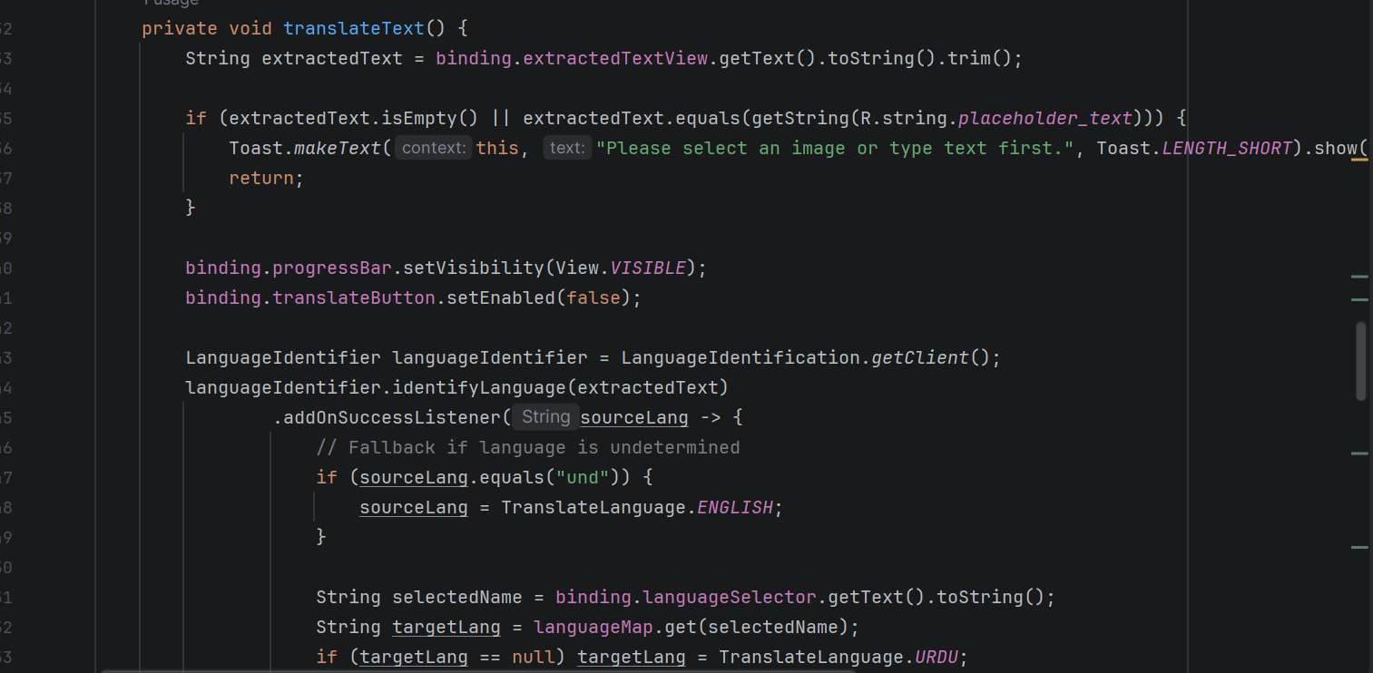
Description: Before translation occurs, this NLP logic detects the source language of the text. A critical fail-safe is implemented: if the language is undetermined, it defaults to English to prevent application crashes, ensuring the translation engine always receives a valid input.
Code Snippet 7: Offline Translation Engine & Model Caching
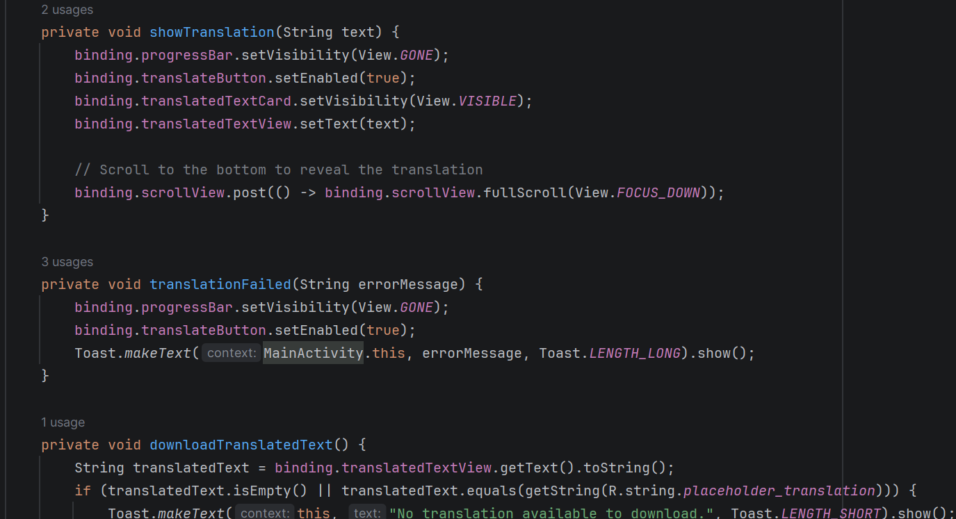
Description: This logic handles the Neural Machine Translation. It checks if the required language model (English, Urdu, or Arabic) exists on the device. If not, it requests a download (downloadModelIfNeeded). Once cached, the model translates the text entirely offline.
Code Snippet 8: Secure File System Export (SAF)
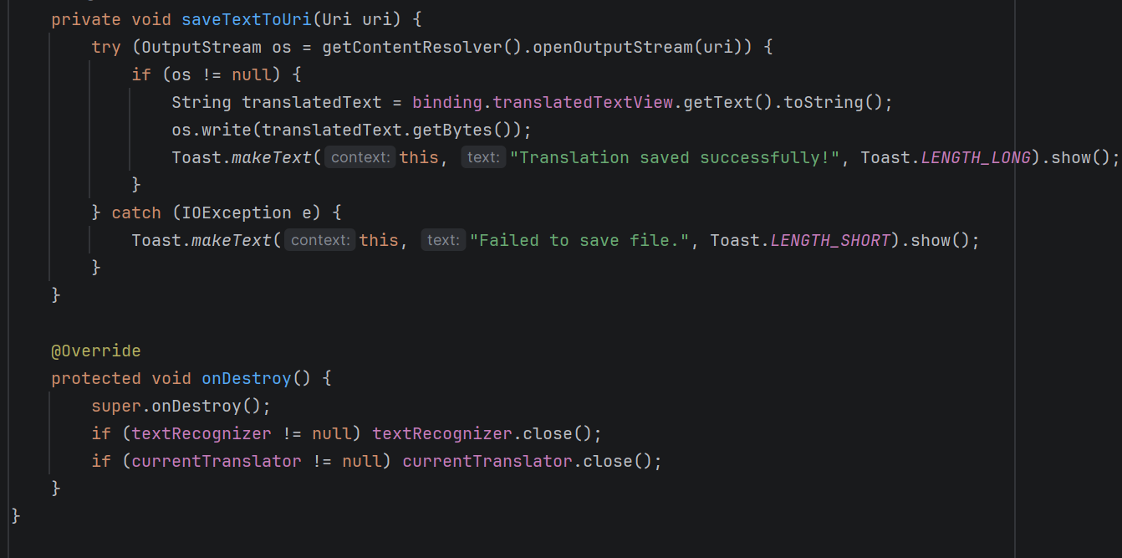
Description: This logic implements the Storage Access Framework (SAF) via ActivityResultContracts.CreateDocument. It allows the user to securely export their translated text as a .txt file to their Downloads folder using an OutputStream, avoiding the need for external write permissions.
2. Application Output & User Interface:
The following screenshots demonstrate the application's user flow, highlighting the premium Material Design styling and offline translation capabilities.
Output 1: Initial Launch & Academic Scanner Interface
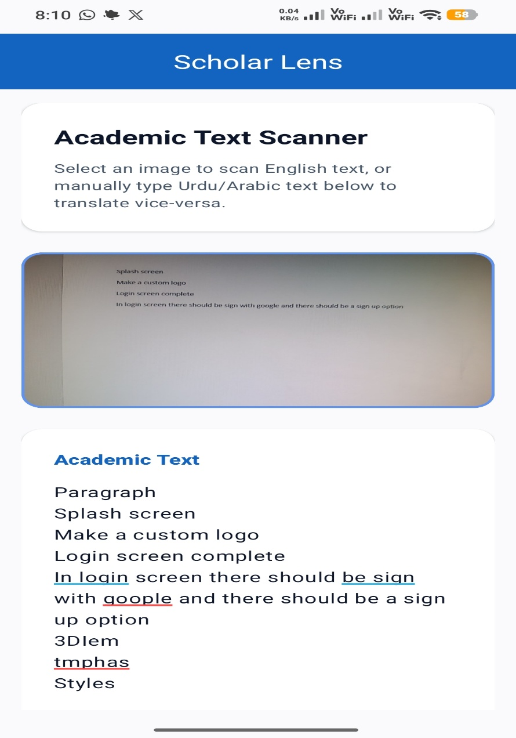
Description: The primary user interface features clear typography, elevated Material cards, and the custom Oxford Blue color palette. The interface instructs the user on how to use the scanner, guiding them to tap the camera placeholder to securely select a document.
Output 2: OCR Extraction & Editable Interface
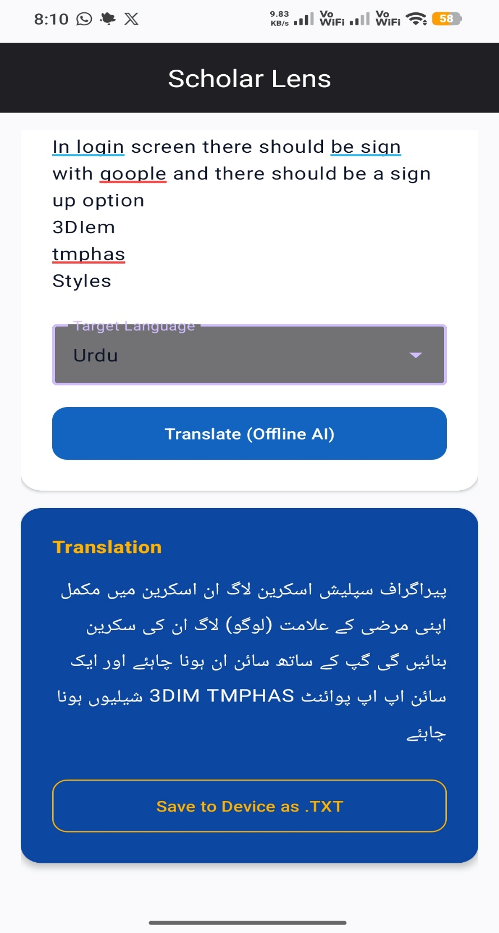
Description: Upon selecting an image, the on-device AI instantly extracts the academic text. The extracted text is displayed in an editable Material Card, allowing users to manually type or fix text (enabling bidirectional Urdu/Arabic support). Below it is the dropdown menu to select the target language.
Output 3: Offline Translation Result
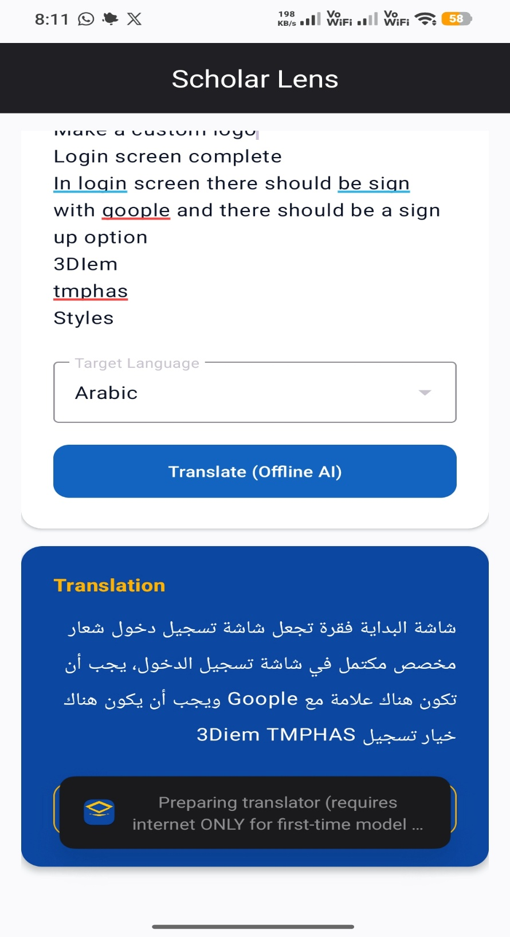
Description: The final output displays the translated text securely within the application. The translation card utilizes a contrasting dark theme (primaryDarkColor) to distinguish it from the original text. The "Translate" button triggers the on-device NMT model to generate this result without cloud processing.
Output 4: File Export and System Integration


Description: This screenshot demonstrates the final feature of the application: secure file export. By clicking the outlined "Save to Device as .TXT" button, the user successfully exports the translated text to their device storage, confirmed by the system Toast notification.

-: THE END :-

